CSA0501-DATABASE MANAGEMENT SYSTEMS
LAB EXPERIMENTS DATE: 24/08/2026
K.SARANYA(192424409)

EXPERIMENT 16 -- HIGH LEVEL PROGRAMMING EXTENSIONS - PROCEDURES

AIM:
To implement procedures using programs in MySQL.

PROCEDURES:
A procedure is a subprogram that performs a specific action. The CREATE PROCEDURE statement is used to create a stored procedure. The DELIMITER command is used to change the standard delimiter so that multiple statements can be treated as a compound statement.
Calling a stored procedure:
CALL stored_procedure_name();

PROCEDURE:
1. Open MySQL Workbench and select the Flight_Reservation database.
2. Create a simple procedure to display records from the Passenger table.
3. Create a procedure that accepts a passenger ID and returns a passenger level based on the total amount paid.
4. Execute the procedures using CALL statements.
5. Verify the results.

PROGRAM - 1:
Create a simple procedure to get all the records from the Passenger table.
USE Flight_Reservation;
DROP PROCEDURE IF EXISTS GetAllPassengers;
DELIMITER //
CREATE PROCEDURE GetAllPassengers()
BEGIN
SELECT * FROM Passenger;
END //
DELIMITER ;
CALL GetAllPassengers();
OUTPUT:
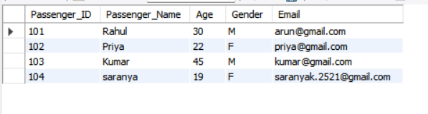

PROGRAM - 2:
Create a stored procedure GetPassengerLevel() that accepts a passenger number and an output parameter. The level is determined from the passenger's payment amount: PLATINUM for 7000 or above, GOLD for 5000 or above, otherwise SILVER.
DROP PROCEDURE IF EXISTS GetPassengerLevel;
DELIMITER //
CREATE PROCEDURE GetPassengerLevel(
IN p_passenger_id INT,
OUT p_passenger_level VARCHAR(20)
)
BEGIN
DECLARE total_amount DECIMAL(10,2);
SELECT COALESCE(SUM(PM.Amount), 0)
INTO total_amount
FROM Booking B
LEFT JOIN Payment PM
ON B.Booking_ID = PM.Booking_ID
WHERE B.Passenger_ID = p_passenger_id;
IF total_amount >= 7000 THEN
SET p_passenger_level = 'PLATINUM';
ELSEIF total_amount >= 5000 THEN
SET p_passenger_level = 'GOLD';
ELSE
SET p_passenger_level = 'SILVER';
END IF;
END //
DELIMITER ;
CALL GetPassengerLevel(101, @level);
SELECT @level AS Passenger_Level;
OUTPUT:
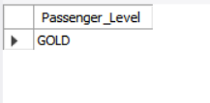

RESULT:
Thus the high level programming procedures were successfully implemented and executed in the Flight Reservation System database.

